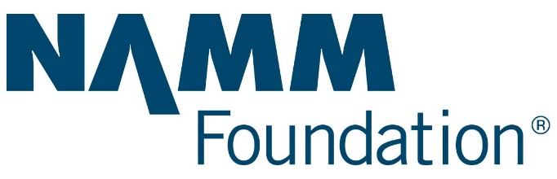

The NAMM President’s Innovation Award

Submission Guidelines

The NAMM President’s Innovation Award honors college students who demonstrate excellence in the field of music and are pursuing careers in music including the music products industry.

To apply, fill out the online application and outline your proven track record of leadership and commitment as a music major. Include why you desire to explore career opportunities in music including music education, performance, music products, production, administration, management and/or marketing along with product creation and innovation.

Recipients receive a one-time cash award of $600 to go toward travel expenses to attend The NAMM Show, the annual global music products trade show in Anaheim, CA January 24-27, 2019. Award winners attend professional development opportunities and receive access to more than 1,800 music products, pro audio and live event technology exhibits, in addition to concerts, special events and networking sessions.

* Applicants must be undergraduate and graduate-level college and university students currently enrolled in music and/or music business or music education programs to be eligible. The Innovation Award seeks to support individuals who exhibit commitment and aptitude for business leadership and innovation in the music products industry.

If you have any questions regarding this application, please contact The NAMM Foundation at least 24 hours in advance of the application deadline at grants@namm.org.
Application Deadlines
Application Cycle Opens | Application Cycle Closes | Award Notifications
June 15, 2018 | September 30, 2018 | November 1, 2018

How to Apply

Please read fully before completing all requirements via The NAMM Foundation’s online application system. The information below will help you with your application.

To be considered for this award, please note that you must demonstrate an overall grade point average of 3.0 or higher. Applicants must also currently be enrolled (and continue to be enrolled through the winter/spring semester 2019) in a university-level music, music business, music education and/or music technology program.

If you have a Cybergrants record associated with another NAMM Scholarship, please create a new record and “start a new application” via the link for the President’s Innovation Award. Only completed applications submitted by the stated deadline will be considered. Thank you in advance for your cooperation.

Step 1: Go to www.cybergrands.com/

Step 2: Log in or Create an Account

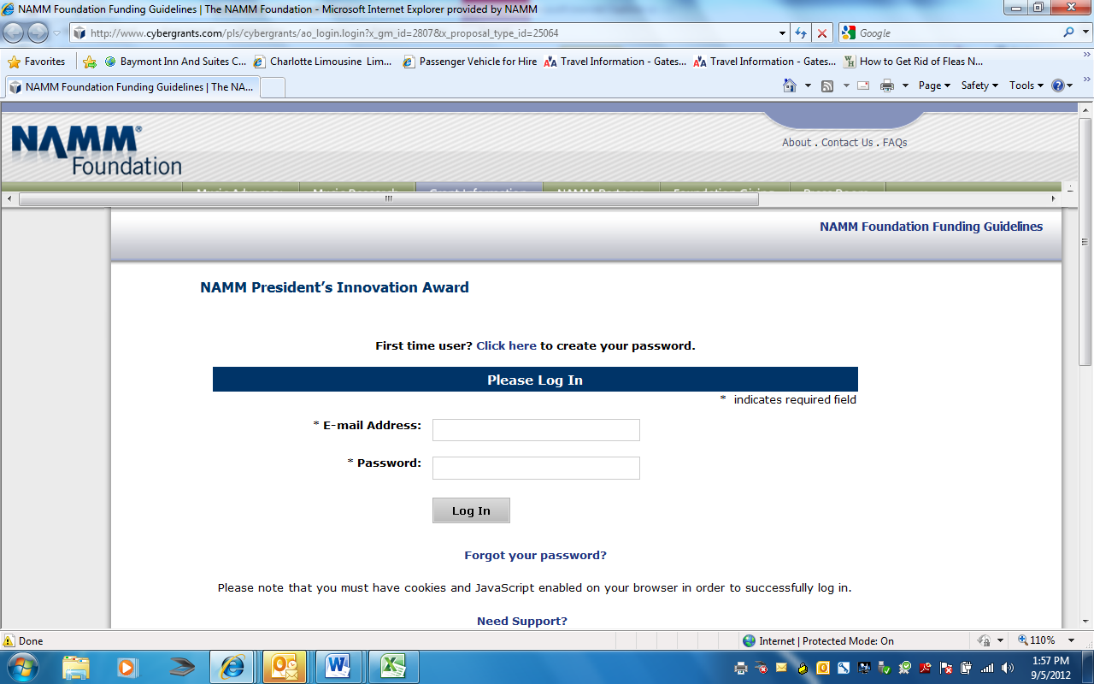
IMPORTANT NOTE: For field “Organization name” enter the first and last name of the student— do not enter the name of your college.

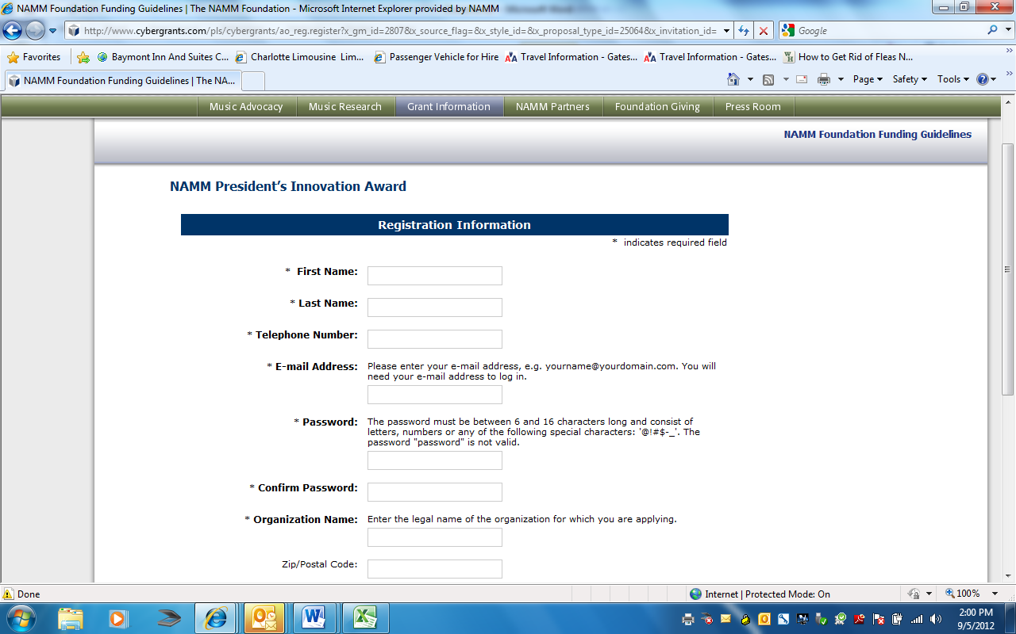

IMPORTANT NOTE: For required field “NAMM Fiscal Year,” please enter “2019”

Step 3: Describe Your Accomplishments

a. Please specify your academic level and the year of your college or university enrollment during which time you are seeking a travel award. (required)
(i.e. Freshman Semester I and II; etc.).

b. Please list all high school(s) and college(s) attended, graduation date(s) and diploma/certificate(s) received. (required)

c. In what organization(s) have you taken part during the past three years? (required)
Please include community organizations, government, student government, literacy activities (newspaper, yearbook publications), dramatics, musical activities, clubs, service organizations and athletics.

d. Describe any special recognitions, honors or prizes received during the past five years. (required)

e. Describe your leisure interests or hobbies, noting any accomplishments in the area of music. (required)

f. Upload your resume or a document that lists the jobs (including summer employment) you have held in the past three years. (required)

Step 4: Share Your Future

a. Describe the one interest or activity (in or out of school) which has engaged most of your time and energy within the past three years and to which you have made the strongest commitment. How do you evaluate the results of your involvement in this endeavor? (required)(word count 100-200 words)
Describe your role (s) and contribution (s).

b. Discuss your plans for the next five years, including your choice of career, and how you plan to prepare yourself for that career. (required)

c. Submit an essay of no more than 500 words demonstrating your unique interest in pursuing a career in music and/or the music products industry and what you expect the experience of attending The NAMM Show will provide. (required)

d. Why do you feel you are qualified to be a recipient of The NAMM President’s Innovation Award? (required)

e. Please provide a summary of known travel expenses for which funds are requested; detail how award funds will be applied toward those travel costs. (required)

Step 5: Upload Supporting Documentation

a. High School or College Transcript (required)
Please upload a Spring 2018 transcript indicating you are a full-time student enrolled in coursework related to music and business with an overall 3.0 grade point average.

NOTE: If you scan your transcript, please keep file size as small as possible while keeping the scan legible.

b. Two Letters of Reference (required)
Please include a minimum of two letters of reference including one from a current employer, if applicable. If you are or have worked for a music business please include a letter of reference from your supervisor. If a letter of reference from a current or past employer cannot be secured, provide a second letter from a current faculty member.

c. FAFSA Identification Number
If you are currently enrolled in a college or university or have accepted a position for your freshman year, please enter the FAFSA Identification Number of the college or university.

Congratulations! You’ve completed the application!

Award Recipients

If you are selected as an Innovation Award recipient, you will be notified by November 1, 2018. A grant agreement letter signed by you and co-signed by a faculty member or advisor will be required. After this signed agreement is received by The NAMM Foundation, funds will be disbursed to help cover travel expenses to The 2019 NAMM Show January 24 – 27, 2019. Should you leave college prior to completing the fall 2018 semester and/or not be enrolled for the winter 2019 semester, the award is forfeited and funds must be returned to The NAMM Foundation.

Please note Innovation Award Recipients are responsible for their own transportation and housing. Dates for The 2019 NAMM Show are January 24-27, 2019. Attendance is required at our GenNext events on Saturday, January 26:
- The Grand Rally for Music Education Rally, 9:30 am
- NAMM President and CEO Meet and Greet, 3 pm
- The Crane Institute for Music Business Presents the Sandy Feldstein Industry Roundtable, 4 pm

Award recipients will be required to submit an impact report of their experience at The NAMM Show no later than February 28, 2019. Report requirements and submission details will be available online.

Innovation Awards are given once during a student’s academic career and are not renewable; recipients are not eligible to reapply for the same award.

If you have any questions regarding this application, please contact The NAMM Foundation at least 24 hours in advance of the application deadline at grants@namm.org.

