**Forming Chords from the C Scale**

Melody (what you would sing) comes from the chords that are played to accompany that line of music. We use the notes of the scale to form the chords used to accompany our melody line.

**C Chord**: The First chord of the C Scale is formed using the 1st, 3rd, and 5th notes of the C Scale

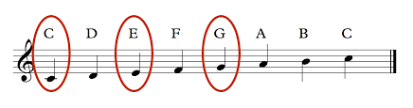

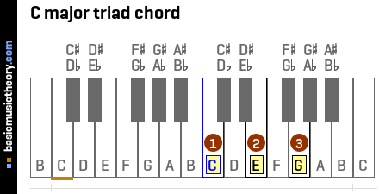

**F Chord**: The 4th chord of the C Scale is formed using the 4th, 6th, and 1st notes of the C Scale. These would be the 1st, 3rd, and 5th notes of the F scale.

Pitch: C D E F G A B C D E

Note #:1 2 3 4 5 6 7 1 2 3

**G7 Chord**: The 5th chord of the C Scale is formed using the 5th, 7th, and 9th, and 11th notes of the C Scale. These would be the 1st, 3rd, 5th, and flated (b) 7th notes of the G scale.

Pitch: C D E F G A B C D E F

Note #:1 2 3 4 5 6 7 1 9 10 11

Pitch: G A B C D E *F(~~#~~) G

Note #:1 2 3 4 5 6 7 1

**Accompanying the C Scale with the I, IV, V7 chords:**

Pitch: C D E F G A B C

Note #: 1 2 3 4 5 6 7 1

Chord: C G7 C F C F G7 C

Chord #:I V7 I IV I VI V7 I