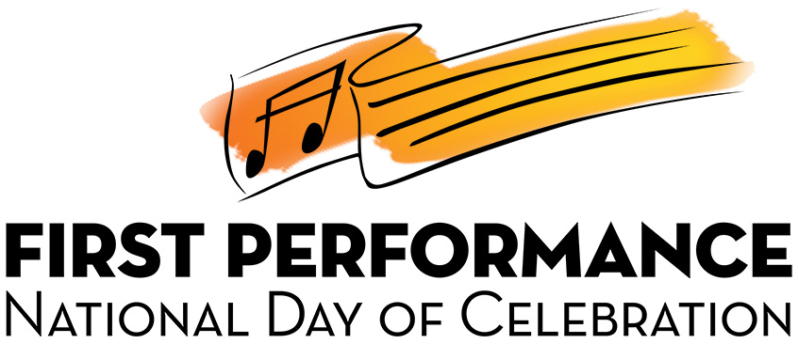

Mozart Middle School Music Department
1234 Lyrical Lane
City, State, ZIP
(000) 000-0000, x000

Dear Parents:

YOU ARE CORDIALLY INVITED TO OUR FIRST PERFORMANCE NATIONAL DAY OF CELEBRATION!

It gives us (me) great pleasure to announce our FIRST PERFORMANCE NATIONAL DAY OF CELEBRATION, a short demonstration concert featuring this year’s Beginning (Band, Orchestra, Strings) Class, scheduled for (date). This is an exciting event that you won’t want to miss. Students will demonstrate what has been learned up to this point and your attendance will help motivate them to perform at their very best.

We also want to look our best for our FIRST PERFORMANCE so we are requesting that the boys wear dark pants with white shirts and the girls wear dark skirts or pants with white blouses. Students must arrive by (time) for seating, tuning and warm-ups and should meet (location).

Our FIRST PERFORMANCE will begin promptly at (time) and the entire presentation should last approximately 20-30 minutes. Refreshments will be served immediately following the program and certificates will be presented to each student musician to celebrate this major achievement.

Please join us and bring all of your friends and family members. Also, be sure that your device is fully-charged as there will be many opportunities to take photos and record videos so that you and your child can enjoy this special moment for many years to come.

We are looking forward to seeing you at our FIRST PERFORMANCE NATIONAL DAY OF CELEBRATION.

Sincerely,

Name of Director
director@mozartms.edu

