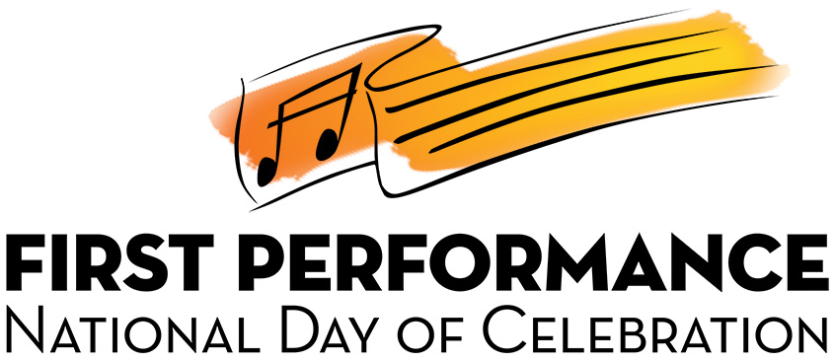

Mozart Middle School Music Department
1234 Lyrical Lane
City, State, ZIP
(000) 000-0000, x000

Dear Mr./Mrs. Principal:

It gives us (me) great pleasure to announce our FIRST PERFORMANCE NATIONAL DAY OF CELEBRATION, a short demonstration concert scheduled for (date) featuring this year’s Beginning Band (Orchestra, Strings) Class. We (I) would like to invite you to serve as host by announcing the program. A script is being provided or you could certainly feel free to use your own words for this impactful 20-minute program.

FIRST PERFORMANCE is part of a National Day of Celebration designated for recognizing beginning music students. It will give you an opportunity to see first-hand what is being accomplished in the band (orchestra, strings) program. Students will demonstrate what has been learned up to this point and your participation will help motivate them to perform at their very best. Your presence will also show our students and their parents that you support (name of school)’s Music Program and are interested in seeing how they progress. We expect to have (number) parents and friends in attendance.

Our FIRST PERFORMANCE will begin promptly at (time). We are encouraging families to take photos and record videos so that they may enjoy this special moment for years to come. Refreshments will be served immediately following the performance and we would be grateful if you could also assist in the handing out of the Certificates of Achievement to each of the student musicians at this post-concert celebration.

This is an exciting event that you won’t want to miss. Please join us so that we may celebrate this FIRST PERFORMANCE NATIONAL DAY OF CELEBRATION together.

Sincerely,

Name of Director

