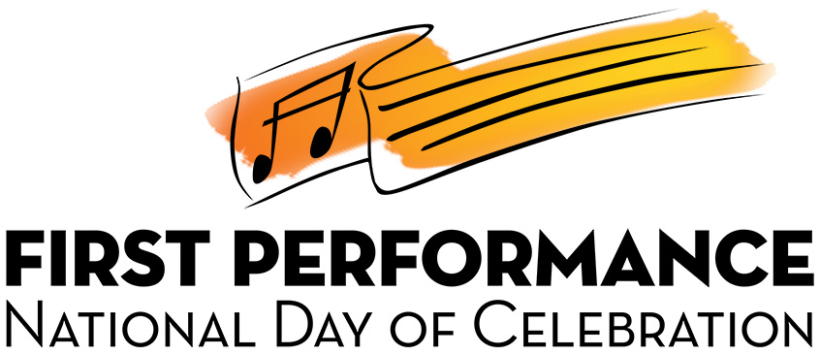

SCRIPT

OPTIONAL INTRODUCTION: (Industry Spokesperson)

Good Evening/Afternoon,

Welcome to (name of school)’s FIRST PERFORMANCE NATIONAL DAY OF CELEBRATION. I’m (name) representing (name of business). I appreciate (director) inviting me to make a few comments about this exciting event! We have found that young people are motivated to learn to play a musical instrument for a number of reasons but many times, it’s because it just looks like fun—and it is!

We are pleased to be a part of this FIRST PERFORMANCE NATIONAL DAY OF CELEBRATION and are here representing the Music Achievement Council, a 501(c)(6) nonprofit organization which believes in the important and value of music education in our schools. Your child will not only have an experience that will lead to a path of enjoyable, life-long music-making, but will also accumulate many great memories that will last for a lifetime.

I am personally proud to support the work of the Music Achievement Council and this FIRST PERFORMANCE program to keep music in our schools and communities so that your children will be able to take advantage of the many benefits that will come along inherently as a direct result of their active music-making.

As a prelude to this evening’s performance, the (band, orchestra, strings, et.al.) will now play a composition they like to use as a warm-up, (title).

Musicians perform

ANNOUNCER’S SCRIPT: (Principal, Supervisor, Booster Parent, HS Band or Orchestra Director)

Good evening, Moms and Dads, brothers and sisters, grandmas and grandpas, aunts and uncles, friends and neighbors! It is a thrill for us to present these young musicians in the (year) FIRST PERFORMANCE NATIONAL DAY OF CELEBRATION—a day that has been designated for recognizing the achievements of beginning music students! We know that you will be pleasantly surprised at their many accomplishments over these first several weeks.

Not every child is fortunate enough to have the opportunity to play a music instrument through an in-school music program but we at (school) value music education and know that it is programs like these that also teach the skills needed for our students to succeed throughout their school careers. Playing an instrument takes physical coordination and mental concentration. It also takes regular practice time at home and your efforts to support them makes all the difference. All of the musicians here tonight have demonstrated the ability and desire to play and have thus earned membership in the (school) (band orchestra, strings, et.al.) program.

In this evening’s (today’s) performance, the students will demonstrate what they have learned up to this point in their brief, but successful, musical careers. After learning how to take the instrument out of the case and assemble it, they finally got to do what they had been wanting to do—produce their first sound.
It sounded something like this.

Musicians play the most awful sound possible with great enthusiasm!

It was obvious they had some challenges facing them for the next few days and (director) had to wonder what was possible.

The second week proved to be quite eventful. (director) worked patiently with the students until they could all produce their first note. Now they sounded like this.

Musicians play a whole note in unison with their very best sound.

Quite an improvement, but they needed a lot more work to be ready for our performance.

Producing that first note allowed them to continue through those first few lessons where they also learned to count while they played. This is important to help them learn to play together as a team.

Musicians play one of their first exercises but not a recognizable tune.

Once they learned how to count, they added different rhythms to those first notes and the music began to take shape.

Musicians play one of their rhythmic exercises but not a recognizable tune.

This is certainly more interesting than the first note, but it is still not a complete tune that you might identify. They learned a few more new notes and discovered they could link them together to play a tune you could recognize. This might have been the moment at home when you felt, for the first time, that the music lessons were starting to take hold. This is what they sounded like at school that day.

Musicians play a recognizable tune.

The students continued to follow this step-by-step process and as they completed each step, everyone was convinced that this was going to be one of our finest beginning (band, orchestras, string groups, et.al.) ever! Here is one of their favorite pieces.

Musicians play their favorite tune.

OPTIONAL SECTION:

(Note to director) This is where you ask for volunteers to play as an individual, a group or a complete section. Have as many students perform as you wish. This allows parents to hear a variety of instruments and levels of musicianship. Be sure to have extra stands and music up front.

Although time doesn’t permit us to have each student perform individually, we have asked a few volunteers to play solos, duets or as a small group.

Our first student(s) is (are) who will perform (title) on the (instrument/s).

(Repeat for each individual or group)
CONCLUSION:

Our (band, orchestra, strings group, et.al.) has come a long way since that first note and they have worked very hard to prepare this FIRST PERFORMANCE in such a short time. This has certainly been an exciting performance for all of us and we’re glad that you were here to help celebrate this important milestone. Support at home is vital if your son or daughter is going to continue to progress at this quick pace so please feel free to visit with (director) for ideas on how to support your child’s practice schedule. You can be sure that (he, she) is looking forward to communicating with you as your child advances.

Our next performance will be presented on (date) at (time) and will be held (location). Please plan to join us as we continue our musical journey.

We will now present our final selection, (title).

(Musicians perform.)

Ladies and gentlemen, you have just witnessed (name of school)’s (year) FIRST PERFORMANCE DAY OF CELEBRATION. How did they do?
(Encourage thunderous applause.)

We are very pleased and gratified with the achievements of our young musicians and look forward to their continued musical growth.

At this time, the students are going to pose for pictures so we would like to invite you to join us to get a good close up of your child performing. Once everyone gets their photos, our musicians will need a few minutes to clean their instruments and put them away properly so please make your way to the refreshment area (give directions) and we will meet you there shortly to award the students with their certificates.

Thank you again for attending and participating in our FIRST PERFORMANCE NATIONAL DAY OF CELEBRATION.

